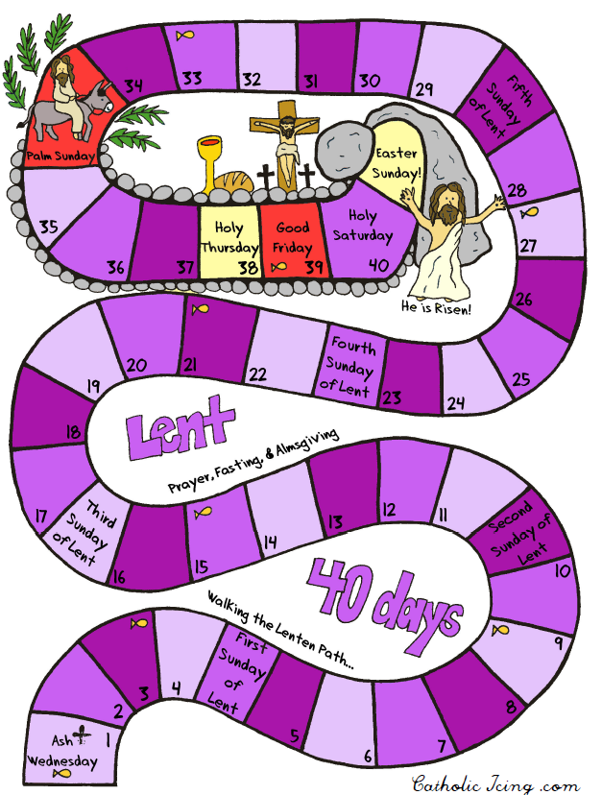

**REMEMBER! Get your coloured sticker at the end of each Lenten Mass or Lenten Activity you attend or participate in. Try to collect as many as you can in & out of school!**

**St. Joseph’s**

**Day**

**The Annunciation**

**21/4/19**

**20/4/19**

**19/4/19**

**18/4/19**

**17/4/19**

**16/4/19**

**15/4/19**

**13/4/19**

**12/4/19**

**11/4/19**

**10/4/19**

**09/4/19**

**08/4/19**

**06/4/19**

**05/4/19**

**04/4/19**

**03/4/19**

**02/4/19**

**01/4/19**

**29/3/19**

**29/3/19**

**28/3/19**

**27/3/19**

**26/3/19**

**25/3/19**

**23/3/19**

**22/3/19**

**21/3/19**

**20/3/19**

**19/3/19**

**18/3/19**

**16/3/19**

**15/3/19**

**14/3/19**

**13/3/19**

**12/3/19**

**11/3/19**

**9/3/19**

**8/3/19**

**7/3/19**

**Start here!**

**6th March**

CARDINAL NEWMAN HIGH SCHOOL DEPARTMENT OF RELIGIOUS EDUCATION

**Name:**

**Class:**