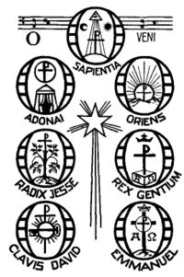

**The O Antiphons** are seven short verses sung before the Magnificat during Evening Prayer of the Church on the seven days before the vigil of Christmas. They each begin with the exclamation "O".

Each of them ends with a plea for the Messiah to come. As Christmas approaches the cry becomes more urgent.

The **O Antiphons** were composed in the seventh or eighth century when monks put together texts from the Old Testament which looked forward to the coming of our salvation. They form a rich mosaic of scriptural images. They became very popular in the Middle Ages. While the monastic choirs sang the antiphons the great bells of the church were rung.

*What do each of the Antiphons mean?*

*Match each Latin Antiphon to its correct meaning.*

Clavis David Wisdom from the most high

Emmanuel Lord of Israel

Radix Jesse Rising Dawn

Rex Gentium God with us

Adonai King of the Gentiles

Oriens Key of David

Sapientia Root of Jesse