**ADVENT**

**S2**

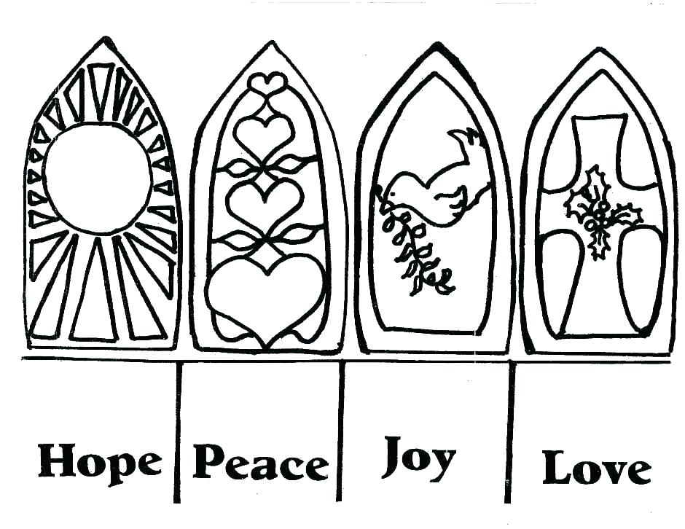

**St. Andrew’s and St. Bride’s High School**

**Chapter 1: What is Advent?**

**Aim:**

I am learning to consider the liturgical events of Advent and Christmastide.

**What is Advent?**

**Advent is a term from the Latin word ‘adventus’ which means “arrival”.** It is a time of waiting for the arrival of Christmas, the coming of Jesus to earth when he wasborn as a baby at Bethlehem,about two thousand years ago. The Jews at the time of Jesus were a people under the authority of Rome. The Romans mistreated the Jews and taxed them heavily.

Many prophets told of God’s promise of a Messiah who would save the Jewish people and prepared the way for the coming of God’s own Son, Jesus. The mystery of God becoming human in the person of Jesus is called the **Incarnation**. The colour purple, used during Advent, symbolises the mood of waiting and preparation for the one who is promised. The colour also represents the **messianic prophecy**.

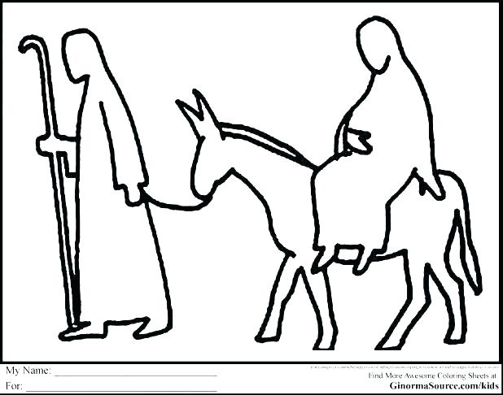The Jews had always been told by the prophets to expect a Messiah who would set them free and make Israel great this had been the dream of Jews for centuries. They believed that he would:

* Be born of a virgin (Isaiah 7.14)
* Will be born in Bethlehem (Micah 5:2)
* He would end up in Egypt (Hosea 11:1)

Waiting is a common human experience. Waiting is not passive. It implies getting ready, even if it is an interior getting ready – psychologically, mentally, and spiritually. Advent can remind us of all the waiting times in life. As we wait for Christmas, are we aware that we join a long history of people who waited?

* We wait with all the people of Israel who waited for the Messiah.
* We wait with Mary and Joseph, Elizabeth and Zechariah, Anna and Simeon.
* We wait in unity with the long line of people throughout history who waited for Jesus, the promised light and Saviour who would lead people out of darkness and into freedom.

In this unit we will study the Annunciation, the Visitation, the role of John the Baptist, the role of Isaiah and the Nativity. In these stories the great Advent themes of hope and joyful expectation are presented. Mary is a key focus, as the woman of faith who listens to and trusts God’s word in her life. We learn that Mary put her faith in God, Mary is the mother of Jesus and at Christmas we celebrate the birth of Jesus.

We will also consider Matthew’s infancy narrative as the source of the Christmas stories told – the Wise Men or Magi who followed the star to the promised light of Jesus and the Holy Family’s Flight into Egypt.

During the Advent season we prepare for Christmas.

|  |
| --- |
| **Activity 1**  In pairs, imagine you lived at the time when Jesus was born. In your jotters, compile a script for a TV news programme for Jews at the time of the birth of Jesus. This will them be acted out for the class.  **Success Criteria:**  Use some words that Jews of the time may have associated with the coming of their expected Messiah.  Include what Jews would hope this Messiah would bring for them. |

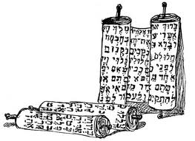**In the beginning it starts here**

Mark begins his Gospel by referring to the Old Testament prophecy of Isaiah. In Mark’s Gospel it is John the Baptist who announces the expectation of the coming of Jesus, referring to the prophecy of Isaiah made hundreds of years earlier.

The prophet Isaiah is the first of four Major Prophets in Hebrew Scripture. The Book of Isaiah is a collection of poems and contains two of the most famous prophecies in Hebrew Scripture, that of the Virgin birth of the Messiah (7:14) and the Servant who suffered and died for our sins (Isaiah 52:13-53:12), identified in the New Testament as Jesus Christ.

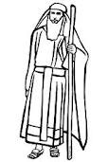

Isaiah 7:14

Therefore, the Lord himself will give you a sign: The virgin will conceive and give birth to a son, and will call him Immanuel.

This passage is used during Advent and Christmas because it applies to Jesus.

|  |
| --- |
| **Activity 2**  Read Isaiah 9:6-7, close the Bible then copy the passage into your jotter and fill in the blanks using the words from the word box  “A _____ is born to us! A son is ______ to us! And he will be our ruler.  He will be called, _______________________, ‘Mighty God’, ‘Eternal  Father’,______________. His royal power will continue to ________;  his kingdom will always be at peace. He will rule as  ________successor, basing his power on right and justice, from now  until the end of ______. The Lord Almighty is _______________to do all this.”  Isaiah 9:6-7  Wonderful Counsellor determined time Prince of Peace given child grow King David’s |

**When does Advent start?**

Advent begins on the Sunday nearest to the 30th November (St. Andrew’s Day) and lasts until midnight on Christmas Eve. Advent Sunday is the first of the four Sundays before the 25th of December.

**What happens during Advent?**

During the season of Advent, Christians across the world prepare for the celebration that marks the arrival of the Lord into the world through the birth of his Son Jesus Christ. Advent is a time to celebrate light in the midst of darkness. It is also a time to look forward to when Jesus will come a second time.

The beginning of Advent is when the preparations for Christmas really begin – the festive menu is planned, gifts are chosen and wrapped, carols sung, cards are written and posted and houses decorated.

**Advent Calendars**

During Advent, some people make or buy Advent calendars as a way of counting the days to Christmas. Usually these calendars have twenty-four ‘windows’.

The calendars do not necessarily start from the beginning of Advent. Advent Calendars always start on the 1st of December.

Traditional calendar windows open up to show a picture of something linked with this time of year. One may show an angel or one of the shepherds who visited baby Jesus. Others may show pictures of Christmas presents, a candle or anything else to do with Christmas. The last window to be opened usually shows Jesus himself, lying in a manger.

|  |
| --- |
| **Activity 3**  Answer the following questions in your jotters:   1. What does the word Advent mean? 2. What do Christians across the world prepare for? 3. What is meant by the term ‘incarnation’? 4. What were some of the prophecies about the Messiah? 5. When does Advent start? 6. Why do you think Advent matters so much for Christians?   **Activity 4**  In pairs you should compile a script of a conversation between 2 Jews in Judea at the time of the birth of Jesus discussing the birth of the messiah. |

**Chapter 2: The Symbolism of the Advent Wreath**

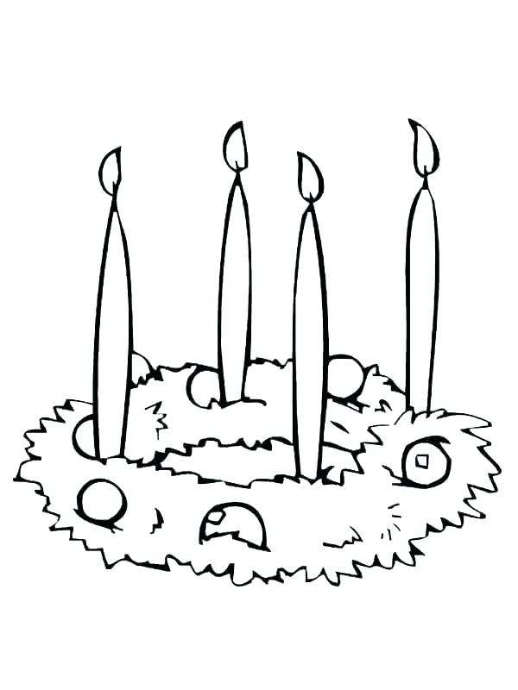**Aim:**

Explore the symbols of the Advent wreath.

It is unknown who invented the Advent wreath, but it is true that the Advent wreath started in Germany as a Lutheran family custom. Since Advent wreaths were originally used in the home, most of the ones you find for sale are small. They didn’t become popular in churches until the middle of the twentieth century. Now they are nearly universal.

**How to make an Advent Wreath**

To begin, put four candles on a wreath or at least in a circle. The evergreen circle represents the everlasting love of God, with no beginning and no end. Traditionally the candles are purple, because in antiquity, purple dye was very expensive and it was the colour of royalty. We use purple for Advent because it is the season of the coming of the King. You can also make one of the candles pink if you like – technically, it is rose coloured. If you have a fifth candle, it goes in the centre of the wreath and it should be white.

**Here are the five candles and their symbolism:**

**First Candle Second Candle**

Colour: Purple Colour: Purple

Theme: Hope Theme: Love

First Sunday in Advent Second Sunday in Advent

**Third Candle Fourth Candle**

Colour: Purple or pink Colour Purple

Theme: Joy Theme: Joy

Third Sunday in Advent Fourth Sunday in Advent

**Optional Centre Candle**

Colour: White

Theme: Christmas

Christmas Day

**Did you know?**

The pink candle has a strange origin. Long ago, the Pope had the custom of giving someone a rose on the fourth Sunday in Lent. This led the Roman Catholic clergy to wear rose-coloured vestments on that Sunday. The effect was to give some relief to the solemnity of Lent, so this was a very popular custom.

Originally – before shopping became a big thing – Advent was a solemn fast in preparation for Christmas, so the custom was extended to the third Sunday in Advent to liven it up a little bit, too. Somewhere in there the third candle of the Advent wreath turned pink. Meanwhile, Advent is no longer solemn and the Pope no longer has the custom of giving out roses. Remember, if the 24th of December is a Sunday, it is the Fourth Sunday in Advent until sundown, at which time it becomes Christmas Eve (Eve means evening after all!).

|  |
| --- |
| **Activity 1**  Answer in your jotter:   1. Why is a circle of green used for the advent wreath? 2. What do the purple advent candles represent? 3. What is the origin of the pink candle? 4. If there is a white candle when is it lit? 5. Why do you think Christians use an Advent wreath? 6. Do you think advent should be a solemn or a joyful time? Give a reason for your answer.   **Activity 2**  Draw the Advent Wreath and colour it correctly. Annotate it with descriptions of what each candle represents. |

**Chapter 3: Advent: The Beginning of the Liturgical Year**

**Aim:**

Explore what makes Advent different to other times in the liturgical year.

**The Liturgical Year**

The Christian Year follows the life of Jesus. It begins with the first Sunday of Advent – which for the Christian church is ‘New Year’s Day’. The most important day of the year will be Easter Sunday, the day on which Jesus came back to life – but before that festival, there will be other special days to look forward to. At the end of Advent, there will be Jesus’ Christmas Day.

**A New Year in December?**

The liturgy follows an annual cycle, like the seasons of the year. The liturgical cycle starts with Advent, a time of preparation for Christmas, when we celebrate the birth of our Lord. After Christmas there is a short period of ordinary time before Lent, the period of penance and preparation leading up to Easter. The Easter Tritium (Holy Thursday, Good Friday, Holy Saturday and Easter Sunday) commemorate the passion, death and resurrection of Christ. Eastertide lasts until Pentecost. After this there is a long period of ordinary time until the end of the liturgical year. These periods are punctuated be commemorations of saints and events in the lives of Jesus and the Holy Family.

**Liturgical Colours**

The colours of the vestments that the priest wears during the liturgy also help express the character of the mysteries being celebrated.

**WHITE** is the colour of joy and victory, is used for the seasons of Easter and Christmas. It is also used for the feasts of Our Lady, for feasts of Mary and the angels and for saints who are not martyrs. Gold may be used on solemn occasions.

**RED** (the colour of blood) is used on days when we celebrate the passion of Jesus on Passion Sunday and Good Friday. It is also used for the birthday feasts of the apostles and evangelists and for the celebration of martyrs. Red (the colour of fire) recalls the Holy Spirit and is used on Pentecost and for the sacrament of Confirmation.

**GREEN** seen everywhere in plants and trees, symbolizes life and hope and is used during Ordinary Time.

**VIOLET OR PURPLE** used in Advent helps us to remember that we are preparing for the coming of Christ. Lent, the season of penance and renewal, also used the colour violet or purple.

**ROSE** may be used on the Third Sunday of Advent, Gaudete Sunday and on the Fourth Sunday of Lent, Laetare Sunday. It expresses the joy of anticipation for Christmas and Easter, respectively.

|  |
| --- |
| **Activity 1**  Copy the diagram below into your jotters and colour the times of the liturgical year, and the vestments worn, correctly. |

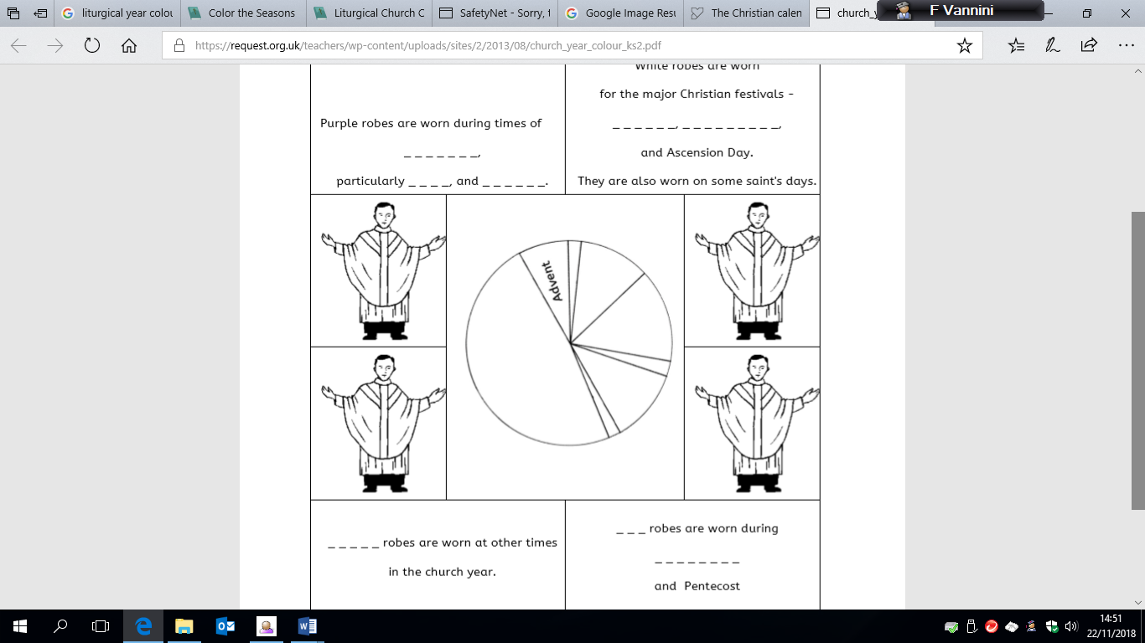

**The Great “O's”**

On the evening of December 17 the final phase of preparation for Christmas begins with the first of the great "O Antiphons" of Advent.  These prayers are seven jewels of liturgical song, one for each day until Christmas Eve.  They seem to sum up all our Advent longing for the Savoir.

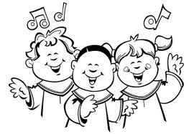***December 17***

**O Wisdom**, that proceedest from the mouth of the Most High, Reaching from end to end mightily, and sweetly disposing all things: come and teach us the way of prudence.

***December 18***

**O Lord and Ruler of the house of Israel**, Who didst appear unto Moses in the burning bush, and gavest him the law on Sinai: come and redeem us by Thy outstretched arm.

***December 19***

**O Root of Jesse**, Who standest as the Ensign of the people, before Whom kings shall not open their lips; to Whom the Gentiles shall pray: come and deliver us, tarry now no more.

***December 20***

**O Key of David**, and Sceptre of the house of Israel; Who openest, and no man shutteth, Who shuttest, and no man openeth: come and lead the captive from the prison house, and him that sitteth in darkness and the shadow of death.

***December 21***

**O Dawn of the East**, Splendour of the eternal Light, and Sun of justice: Come and enlighten them that sit in darkness, and the shadow of death.

***December 22***

**O King of the gentiles**, yea, and the desire thereof, the Cornerstone that makest both one: come and save man, whom Thou hast made out of the slime of the earth.

***December 23***

**O Emmanuel**, our King and Lawgiver, the expectation of all nations and their Salvation: come and save us, O Lord our God.

|  |
| --- |
| **Activity 2**  Read through the first three chapters of this booklet again. Your task is to make up a quiz with ten questions and answers that you can test your partner on. |

**Chapter 4: John the Baptist**

**Aim:**

Assess the importance of John the Baptist, in preparing the way for Jesus.

[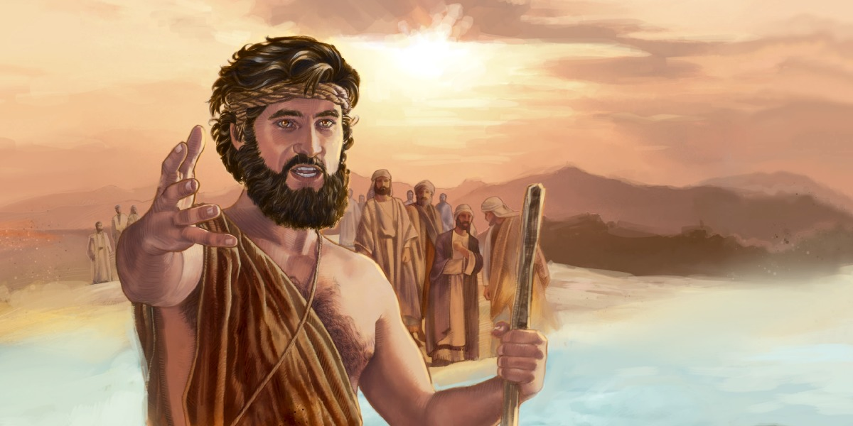](https://www.google.com/url?sa=i&rct=j&q=&esrc=s&source=images&cd=&cad=rja&uact=8&ved=&url=https://www.jw.org/en/publications/books/jesus/events-up-to-jesus-ministry/john-baptist-prepares-way/&psig=AOvVaw0KmHHTzBCPKgJFl-07GZJh&ust=1542986218289158)

John the Baptist is a key figure in the Biblical stories of Jesus Christ. According to the Gospels, John's role was to announce the coming of Jesus. In John 1:23 he tells interrogators, *"I am the voice of one crying out in the wilderness, 'Prepare the way for The Lord make straight paths for Him Make straight the way of the Lord ...* “ (Matthew 3:1-3)

John the Baptist is one of the best-known people of the Bible, and for good reason - he played a unique role in what, and who, was to come. He was considered very highly by Jesus Christ, who said about him, "Among those born of women there has not risen anyone greater than John the Baptist." (Matthew 11:11). One certainly couldn't get a more rock-solid personal reference than that.

|  |
| --- |
| **Activity 1**  Who made the now-infamous request for "*the head of John the Baptist on a platter*"? Matthew 14  **Activity 2**  In your jotters draw a mind map or a spider diagram using the information about John the Baptist on the following page. Make your work as colourful as possible. |

**Facts about John the Baptist**

[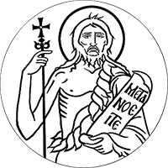](https://www.google.com/url?sa=i&rct=j&q=&esrc=s&source=images&cd=&cad=rja&uact=8&ved=&url=https://stjohndc.org/&psig=AOvVaw2NwczQLUbjHLcAfCKwI0Sw&ust=1542986702341105)

John the Baptist was born 6 months before Jesus Christ (Luke 1:36).

He died about 6 months before Jesus Christ (Matthew 14:10-12).

The angel Gabriel separately announced the coming births of Jesus Christ and John the Baptist.

John lived in the mountainous area of Judah, between Jerusalem and the Dead Sea (Matthew 3:1). "John's clothes were made of camel's hair, and he had a leather belt around his waist. His food was locusts and wild honey." (Matthew 3:4).

John had a popular ministry. "People went out to him from Jerusalem and all Judea, and the whole region of The Jordan, confessing their sins; they were baptized by him in the Jordan River (Matthew 3:5-6).

John the Baptist humbly baptized Jesus Christ. "Then Jesus came from Galilee to the Jordan to be baptized by John. But John tried to deter Him, saying, "I need to be baptized by You, and do You come to me? Jesus replied, "Let it be so now; it is proper for us to do this to fulfil all righteousness." (Matthew 3:13-15)

John's ministry became so popular that some wondered if he was the messiah. He answered, "I am not the Christ, but I am sent ahead of Him." (John 3:28). With the ministry of Jesus Christ then begun, John recognized that his own mission was nearing its end: "He must become greater; I must become less." (John 3:30)

John's ministry, and life, came to an end when he admonished Herod for his sinful behaviour (Luke 3:19-20). He was imprisoned at Machaerus, a fortress about 9 miles (15 kilometres) east of the Dead Sea. There, he was beheaded.

After he was killed, John's disciples came and buried his body, and then went and told Jesus all that had happened (Matthew 14:12). Jesus responded to the news of John's death by saying, "John was a lamp that burned and gave light, and you chose for a time to enjoy his light." (John 5:35)

|  |
| --- |
| **Activity 3**  Read Matthew 3:1-17  The following sentences are not in the correct order. Copy them out into your jotter, putting them in the correct order.   1. John baptized Jesus and the heavens opened and the spirit of God came down like a dove and alighted on Jesus. 2. John the Baptist came to the desert of Judaea and started preaching. 3. But John told the people that he baptized with water, while the one after him would baptize with the Holy Spirit and fire. 4. The people confessed their sins and John baptized them in the river Jordan. 5. A voice from heaven said, “This is my own son, with whom I am well pleased”. 6. John said that it should be Jesus who should be baptizing him. 7. Jesus came to John to be baptized.   **Activity 4**  “Other than Jesus, John the Baptist is the most important person in the Bible”  Do you agree? Give at least two reasons for your answer. |

**Chapter 5: The Nativity Story**

**Aims:**

* Explore the Nativity story.
* Deepen my understanding of the nature of Jesus.

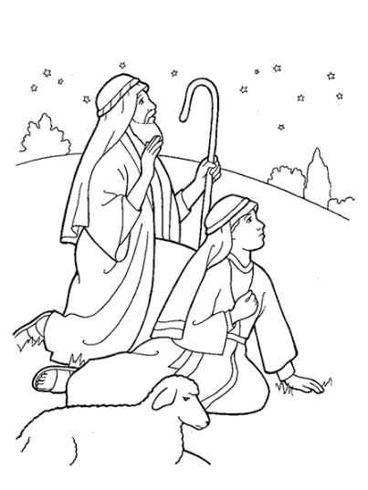

**The Nativity Story**

**Luke 2:1-20**

"Now at that time Caesar Augustus issued a decree for a census of the whole world to be taken and everyone went to his own town to be registered. So Joseph set out from the town of Nazareth in Galilee and travelled up to Judea, to the town of David called Bethlehem, since he was of David's House and line, in order to be registered together with Mary, who was with child. While they were there, the time came for her to have her child, and she gave birth to a Son, her first-born. She wrapped him in swaddling clothes, and laid him in a manger because there was no room for them at the inn. 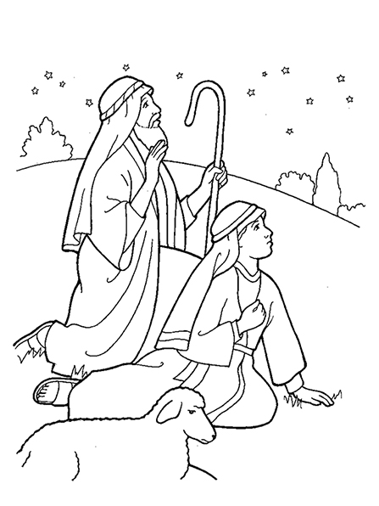

"In the countryside close by, there were shepherds who lived in the fields and took it in turns to watch their flocks during the night. The angel of the Lord appeared to them and the glory of the Lord shone around them. They were terrified, but the angel said,

'Do not be afraid. Listen! I bring you news of great joy, a joy to be shared by the whole people. Today in the town of David a Savoir has been born to you; he is Christ the Lord. And here is a sign for you: you will find a baby wrapped in swaddling clothes and lying in a manger.'

"And suddenly with the angel there was a great throng of the heavenly host, praising God and singing:

Glory to God in the highest heaven, and peace to all who enjoy his favour.

"Now when the angels had gone from them into heaven, the shepherds said to one another, 'Let us go to Bethlehem and see this thing that has happened which the Lord has made known to us.'

C:\Documents and Settings\lmyles\Local Settings\Temporary Internet Files\Content.IE5\OTCP23GR\MC900432403[1].wmf"So they hurried away and found Mary and Joseph, and the baby lying in the manger. When they saw the child they repeated what they had been told about him, and everyone who heard it was astonished at what the shepherds had to say. As for Mary, she treasured all these things and pondered them in her heart."

|  |
| --- |
| **Activity 1**  Imagine you were Mary in the Nativity story you have just read. Create a Twitter or Facebook status to express what was happening and how you were feeling at each of the following points in the story:   1. Mary travelling to Bethlehem 2. Mary realising that there was no room at the inn and that she would have to give birth in a stable 3. A bunch of shepherds showing up to see your new baby because an angel had sent them. |

**The Magi Visit the Messiah or The Three Wise Men**

**Matthew 2:1-3, 7-11**

[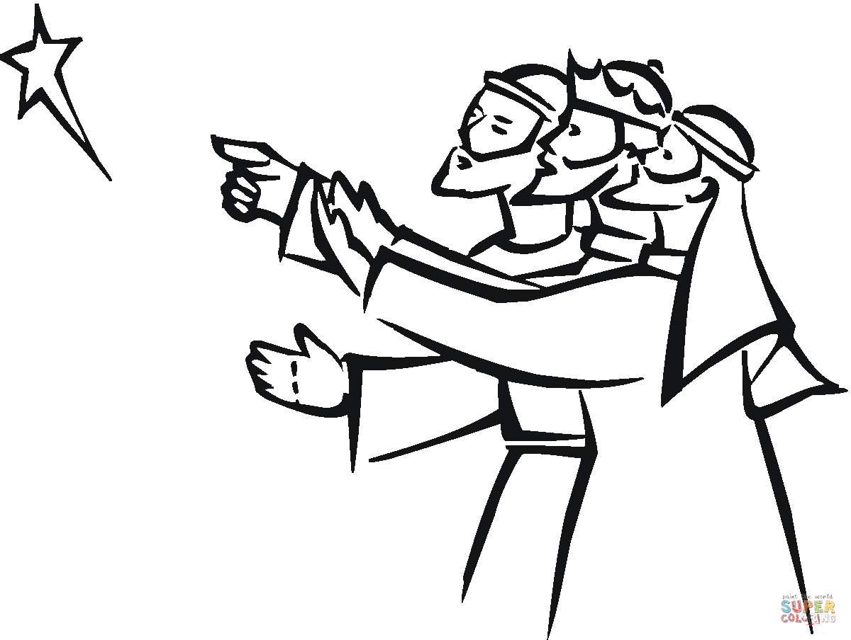](https://www.google.com/url?sa=i&rct=j&q=&esrc=s&source=images&cd=&cad=rja&uact=8&ved=&url=http://www.supercoloring.com/coloring-pages/three-wise-men-pointing-at-christmas-star&psig=AOvVaw02IVS00CVGuuEvgRGPg7LJ&ust=1543403210773511)After Jesus was born in Bethlehem in Judea, during the time of King Herod, Magi from the east came to Jerusalem and asked, “Where is the one who has been born king of the Jews? We saw his star when it rose and have come to worship him.”

When King Herod heard this he was disturbed, and all Jerusalem with him. When he had called together all the people’s chief priests and teachers of the law, he asked them where the Messiah was to be born. “In Bethlehem in Judea,” they replied, “for this is what the prophet has written:

“‘But you, Bethlehem, in the land of Judah,

are by no means least among the rulers of Judah;

for out of you will come a ruler

who will shepherd my people Israel.’

Then Herod called the Magi secretly and found out from them the exact time the star had appeared. He sent them to Bethlehem and said, “Go and search carefully for the child. As soon as you find him, report to me, so that I too may go and worship him.”

After they had heard the king, they went on their way, and the star they had seen when it rose went ahead of them until it stopped over the place where the child was. When they saw the star, they were overjoyed. On coming to the house, they saw the child with his mother Mary, and they bowed down and worshipped him. Then they opened their treasures and presented him with gifts of gold, frankincense and myrrh. And having been warned in a dream not to go back to Herod, they returned to their country by another route. Traditionally the three wise men were called Casper, Melchior and Balthazar.

**Prophecies in the Temple**

After the birth of Jesus, according to St. Luke's Gospel, Mary and Joseph fulfilled what Jewish law customarily required when a child was born. Eight days later, they took Jesus to the temple for the first time. After forty days, they took him to the temple at Jerusalem to consecrate him to God. There the old man Simeon and the old woman Anna recognized the child's extraordinary mission. Taking him into his arms, Simeon said to Mary his mother: "You see this child: he is destined for the fall and for the rising of many in Israel, destined to be a sign that is rejected -- and a sword shall pierce your own soul, too -- so that the secrets of many hearts may be laid bare." Then they returned to Galilee, to their own town of Nazareth.

|  |
| --- |
| **Activity 2**  **Answer the following questions:**   1. Why do you think Herod wanted to kill the baby Jesus? 2. Do you think Jesus was the person this prophecy was talking about? Give a reason for your answer. 3. Why do you think the wise men gave gold, frankincense and myrrh to Jesus, rather than toys or clothes? 4. What prophecy did Simeon make about Jesus? What do you think this meant? 5. What prophecy did Simeon make about Mary? What do you think this meant? |

**The Escape to Egypt and the Return to Nazareth.**

[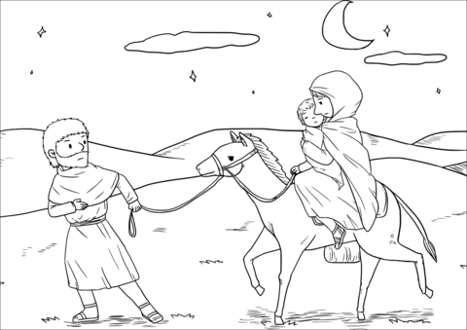](https://www.google.com/url?sa=i&rct=j&q=&esrc=s&source=images&cd=&cad=rja&uact=8&ved=&url=http://www.supercoloring.com/coloring-pages/joseph-took-the-child-and-his-mother-during-the-night-and-left-for-egypt&psig=AOvVaw2OhdyyXcUefb2KdJcHGjJo&ust=1543401230034772)**Matthew 2:13-20**

An angel of the Lord appeared to Joseph in a dream. “Get up,” he said, “take the child and his mother and escape to Egypt. Stay there until I tell you, for Herod is going to search for the child to kill him.”

So he got up, took the child and his mother during the night and left for Egypt, where he stayed until the death of Herod. And so was fulfilled what the Lord had said through the prophet: “Out of Egypt I called my son.”

When Herod realized that he had been outwitted by the Magi, he was furious, and he gave orders to kill all the boys in Bethlehem and its vicinity who were two years old and under, in accordance with the time he had learned from the Magi. Then what was said through the prophet Jeremiah was fulfilled:

“A voice is heard in Ramah,

weeping and great mourning,

Rachel weeping for her children

and refusing to be comforted,

because they are no more.”

After Herod died, an angel of the Lord appeared in a dream to Joseph in Egypt and said, “Get up, take the child and his mother and go to the land of Israel, for those who were trying to take the child’s life are dead.”

|  |
| --- |
| **Activity 3**  We have seen the plight of many refugees in recent years, be it from war or dictators or natural disasters. It is useful to remember that Joseph, Mary and Jesus were refugees too.  If Mary and Joseph were looking for refugee status in Scotland nowadays – do you think we should welcome them? Give a reason for your answer.  **Activity 4**  Read the following prophecies from the Bible, written before Jesus was born:  Isaiah 7:14 Micah 5: 1-4 Zechariah 9:9  Do you think these were fulfilled by Jesus? Give reasons for your answer. |

**Chapter 6 Special Feast Days in the Christmas period**

**Learning Aim:**

Develop my understanding of the significance of special feast days within the Christmas period.

|  |
| --- |
| **Activity 1**  Create a presentation for the class on one of the following feast days within the Christmas period, of your choosing.  This should include:   1. How did the feast day come about? 2. What do people celebrate on this feast day? 3. When is this feast day celebrated? 4. What do people do to celebrate this feast day? 5. Why is this feast day significant for Catholics? 6. Images and colour |

[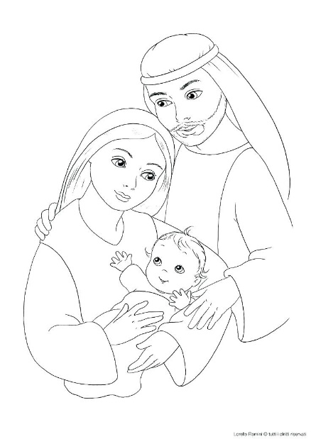](https://www.google.com/url?sa=i&rct=j&q=&esrc=s&source=images&cd=&cad=rja&uact=8&ved=&url=http://beefboys.co/holy-family-coloring-pages/holy-family-coloring-pages-x-icon-page-pictures-color/&psig=AOvVaw2tXTQaqB3NxxBUui9e-ShK&ust=1543403670141991)**The Feast of the Holy Family**

The Feast of the Holy Family is a [liturgical](http://en.wikipedia.org/wiki/Liturgy) celebration in the [Roman Catholic Church](http://en.wikipedia.org/wiki/Roman_Catholic_Church) in honour of Jesus of Nazareth, his mother, the Blessed Virgin Mary, and his foster father, Saint Joseph, as a family. The Feast of the Holy Family commemorates their life together, and the celebration focuses on religious family life. The Feast of the Holy Family is celebrated on the Sunday following Christmas.

The feast of the Holy Family was begun by [Pope Leo XIII](http://en.wikipedia.org/wiki/Pope_Leo_XIII) in 1893 on the Sunday within the period of Christmastide; that is to say, on the Sunday between January 7 through January 13. The Priest wear white vestments during the period of Christmastide, Including all feast days of this period. Catholics are expected to go to Mass to celebrate this special day.

In the Holy Family we see the ordinariness of the life of Jesus, the simple acceptance of Mary and Joseph of the marvels of God. In the daily life of family and community can come close to God. But we have to learn to live centred on God, with respect, mercy and love for each other, for every person.

**The Feast of the Solemnity of Mary, the Holy Mother of God**

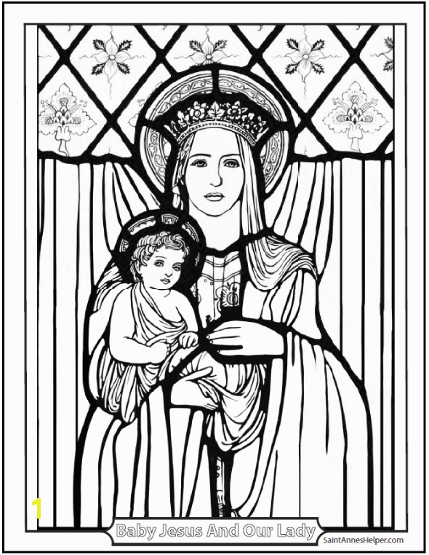Another major feast day of the Christmas period is that of Mary, the Mother of God. The Solemnity of Mary, the Holy Mother of God is a [liturgical feast](http://en.wikipedia.org/wiki/Ranking_of_liturgical_days_in_the_Roman_Rite) of the [Blessed Virgin Mary](http://en.wikipedia.org/wiki/Blessed_Virgin_Mary) honouring her divine motherhood to [Jesus Christ](http://en.wikipedia.org/wiki/Jesus_Christ). It is celebrated by the [Catholic Church](http://en.wikipedia.org/wiki/Catholic_Church) on the 1st of January part of the [Christmas](http://en.wikipedia.org/wiki/Christmas) season. For [Roman Catholics](http://en.wikipedia.org/wiki/Roman_Catholic), this day is designated as a [Holy Day of Obligation](http://en.wikipedia.org/wiki/Holy_Day_of_Obligation) (all Catholics are expected to attend mass on Holy Days of Obligation).

The feast is a celebration of Mary's motherhood of [Jesus](http://en.wikipedia.org/wiki/Jesus). The title “Mother of God” is a way to show the [Divinity of Christ](http://en.wikipedia.org/wiki/Divinity_of_Christ), from which it follows that what is decided predicated by Christ is a decision of God. So, if Mary is the mother of Jesus, she is the Mother of God.

In 1974, Pope Paul VI removed the feast of the Circumcision of Christ from the liturgical calendar and replaced it with the feast of the “Solemnity of Mary, Mother of God”, bringing Mary’s feast day back to the first day of the year. However, the honouring of Mary as the Mother of God can be traced back to the Council of Ephesus in 431.

On this day, we are reminded of the role that Mary played in the plan of our salvation. Through the Holy Spirit, God the Father prepared Mary to give birth to His Son and His Spirit could dwell among men. Christ’s birth was made possible by Mary’s ‘yes’ to God’s plan with her words, “Be it done to me according to thy word”. Calling Mary “Mother of God” is the highest honour we can give to her. Just as Christmas honours Jesus as the “Prince of Peace”, the Solemnity of Mary, Mother of God honours Mary as the “Queen of Peace”.

**The Feast of the Epiphany**[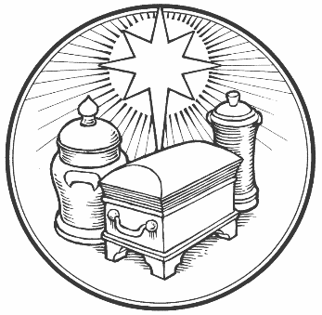](https://www.google.com/url?sa=i&rct=j&q=&esrc=s&source=images&cd=&cad=rja&uact=8&ved=&url=http://www.saintdavidsepiscopal.org/epiphany/&psig=AOvVaw3TvlLCxt3k6IHoi6pEqOrf&ust=1543416830536910)

The Epiphany is celebrated 12 days after Christmas on 6th January, marking the official end to the festive season for many Catholics. The Western Church began celebrating the Epiphany in the 4th century where it was, and still is, associated with the visit of the magi (wise men) to the infant Jesus when God revealed himself to the world through the incarnation of Jesus. According to Matthew 2:11 they offered him gifts of gold, frankincense and myrrh.

Festivities for the ancient Christian feast day vary around the world, from swimming in icy waters to exchanging presents, fireworks and parades. In many countries the day is a public holiday.

It's a big and important festival in Spain, where it's also known as 'The festival of the three Magic Kings' - 'Fiesta de Los tres Reyes Mages', and is when Spanish and some other Catholic children receive their presents - as they are delivered by the Three Kings! In Spain on Epiphany morning you might go to the local bakers and buy a special cake/pastry called a 'Roscón' (meaning a ring shaped roll). They are normally filled with cream or chocolate and are decorated with a paper crown.

[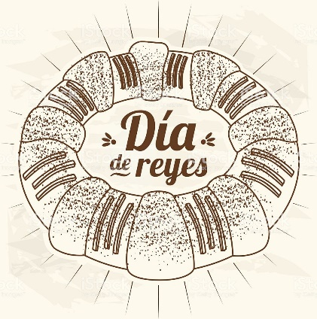](https://www.google.com/url?sa=i&rct=j&q=&esrc=s&source=images&cd=&cad=rja&uact=8&ved=&url=https://www.istockphoto.com/vector/three-kings-day-composition-gm635914186-112494881&psig=AOvVaw2FPDAVr4hwVGTkddv90w8N&ust=1543416897742397)In France you might eat a 'Galette des Rois', a type of flat almond cake. It has a toy crown cooked inside it and is decorated on top with a gold paper crown.

There are similar traditions in Mexico where Epiphany is known as 'El Dia de los Reyes' (the day of The Three Kings). It's traditional to eat a special cake called 'Rosca de Reyes' (Three Kings Cake). A figure of Baby Jesus is hidden inside the cake. Whoever has the baby Jesus in their piece of cake is the 'Godparent' of Jesus for that year.

In Portugal, people take part in Epiphany carol singing known as the 'Janeiras' (January songs). On the Island of Maderia they're known as the 'Cantar os Reis' (singing the kings).

At Epiphany in Belgium, children dress up as the three wise men and go from door to door to sing songs and people give them money or sweets, kind of like Trick or Treating on Halloween. Children in Poland also go out singing on Epiphany.

[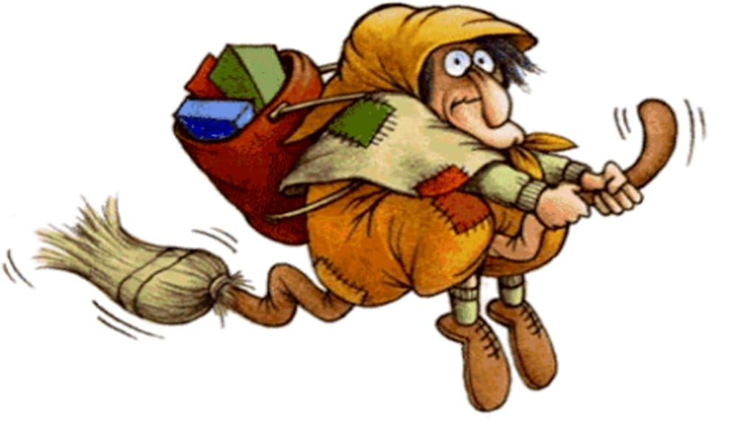](https://www.google.com/url?sa=i&rct=j&q=&esrc=s&source=images&cd=&cad=rja&uact=8&ved=&url=http://www.veronasera.it/eventi/falo-epifania-befana-falo-brusa-la-vecia-bardolino-6-gennaio-2017-.html&psig=AOvVaw204iIymi57yMEw2bjRjZqc&ust=1543417022052677)In Italy, some children also get their presents on Epiphany. But they believe that an old lady called 'Befana' brings them. Children put stockings up by the fireplace for Befana to fill.

Epiphany Eve (also known as Twelfth Night) marks the end of the traditional Christmas celebrations and is the time when you were meant to take Christmas decorations down.

The Roman Catholic tradition, observe Epiphany as a single day, with the Sundays following Epiphany are counted as Ordinary Time.

|  |
| --- |
| **Activity 2**  Answer the following question:  “Scotland should start celebrating the Epiphany the way they do in other countries” Do you agree? Give reasons for your answer. 4 marks |