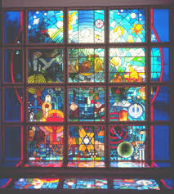 Carfin Lourdes Grotto – The Spirit of Pilgrimage Exhibition
The Pilgrimage Centre opened in 1997, featuring an exhibition of the history of different faiths and beliefs, as well as displaying various religious artefacts. This allows us to recognise that God loves us all – every man woman and child of this earth.

Take a photo of what you see.
Write something OR
tell an adult what you find out.

- A pilgrimage is a type of journey to a special place

- To which ‘special place’ do Jewish people travel to on pilgrimage?
Tick the correct box.
Lourdes Jerusalem Mecca

- Pilgrims of all faiths visit shrines which are important to their faith. Which of the following is shared by Jews and Christians?
Yad Vashem, Israel Dome of the Rock, Jerusalem
Mount Fiji Walsingham, Norfolk

Stained Glass Window
- Name three symbols in the stained glass window and write down what they mean.
SYMBOL | MEANING

Blue Festival Board
- What is the name of the Muslim Pilgrimage which should take place between the 8th and the 13th days of the 12th month of the Muslim year?

- For Jews, the time to visit Jerusalem is during the Feasts. There are three principle feasts celebrated, from the Festival Board write down what each feast celebrates.
FEAST | WHAT IT CELEBRATES
Feast of the Passover (Pesach)
Feast of Weeks (Shavu’ot)
Feast of Tabernacles

Light Boxes
- Pilgrims of all faiths bring tokens of their journey with them to shrines and back home with them as souvenirs of their visit. Match the following tokens with the correct faiths:

MILK BUDDHISTS

ICONS JAIN PILGRIMS

FLOWERS AND PERFUME GREEK ORTHODOX

GOLD LEAF HINDUS

Carfin Lourdes Grotto History

- Which town/shrine in France inspired the building of the Grotto?

- Who was the parish priest in carfin who had the idea of building such a Grotto?

- During which decade was the Grotto built at Carfin? Please tick

1920’s 1940’s 1970’s

- Which famous saint is associated with the Grotto at Lourdes in France?

General Knowledge
- In which Italian City does the Pope Live?

The Mirrored room

This room is designed to allow people to reflect on their spiritual journey. Take a moment to read the words etched onto the mirrors.
Offer your thoughts to God.

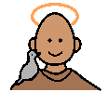
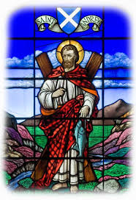
Saints of Scotland

Scotland plays host to many pilgrims and many towns across Scotland are associated with famous saints.

Using the saints of Scotland Board write down the saints associated with each town.

TOWN | ASSOCIATED SAINT
ARBROATH
CAMBUSLANG
CARFIN
DUMFERMLINE
DUNKELD
GLASGOW
PAISLEY
ST KILDA
WHITHORN
WICK

GENERAL KNOWLEDGE – Saints of Scotland Information Board
- Who is Scotland’s Patron Saint?

_______________________________________

- On which island did Saint Columba first arrive?

________________________________________

- St Ninian brought Christianity to Scotland in 394 when he set up his Church. Where was this set up?

_______________________________________

- Who founded Glasgow Cathedral?

______________________________________

- Who is Scotland’s most recent saint and when was he canonised (made a saint)?

_______________________________________

Saints of Scotland Wordsearch

D | U | T | H | A | C
C | K | H | M | F | A
O | I | E | A | E | D
L | L | R | R | R | O
U | D | E | G | G | C
M | A | S | A | M | M
B | O | A | R | I | I
A | P | T | E | R | R
L | S | Q | T | I | I
M | U | N | G | O | N
N | I | N | I | A | N
F | E | R | G | U | S

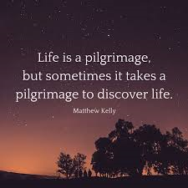
Festivals and saints ACROSTIC
Using all the knowledge you have gained over this day. Complete the following acrostic using the clues below.
(the second answer has been completed as an example for you!)
P. Jewish Feast of Unleavened Bread
I. These pilgrims bring food, perfume, flowers and cloth to a shrine during their pilgrimage.
L. Second name of the parish priest who founded Carfin Grotto
G. The first Bishop and founder of Glasgow Cathedral
R. Famous shrine dedicated to Our lady and St Bernadette in France.
I. Name given to the Glass Chapel in carfin Grotto, “Our Lady _ _ _ _ of the Seas”.
M. Where Muslims go on pilgrimage.
A. Ancient prophet shared by Jews, Christians and Muslims.
G. The most sacred of the seven rivers for Hindu Pilgrims
E. Homeland for Jews, a place of Pilgrimage.
P
hIndus
L
G
R
I
M
A
E

