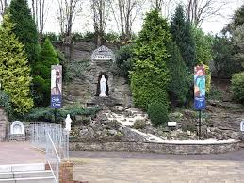
Carfin Lourdes Grotto
This activity involves you walking around this beautiful shrine and finding out a little about the saints and people who are important within the catholic Faith.
Take a photo of what you see.
Write something about the Grotto
Tell an adult what you find out.
Beginning at the entrance to the shrine look to the right (on sign with all the nationalities)

The founder of the Grotto (photograph and info)

The Irish Shrine

The way of Calvary
There are two special areas in this garden (the Divine Mercy Chapel and the House of Nazareth)
Divine Mercy Chapel | House of Nazareth

17. The shrine of St Peregrine
Patron saint of

- Glass Chapel and Bethlehem Cave.

