The lilies of the field

This meditation is taken from the book Guided Meditations for Children by Jane Reehorst BVM which is now out of print and therefore reproduced here. Please advise if the books is reprinted and the reproductions will be removed from the website.
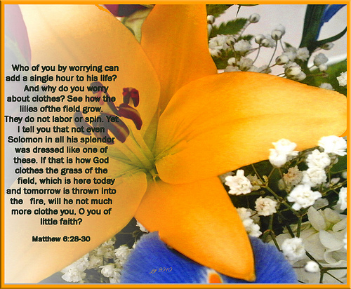
Matthew 6: 25-34 and Luke 12: 22-31

Meditation
Say: Close your eyes. Take a deep breath, and relax.
You are standing in a green field. It is a warm spring day. Look around you, and see the beauty of this place .... Notice that the sky is blue. There is just one fluffy, white cloud floating by .... Feel the warm sun on your head .... Begin to walk through the field. The weeds that brush against your legs tickle, don't they? And look at all the flowers everywhere- yellow, pink, white, and blue-so many, beautiful colours .... Listen to the bees buzzing around the flowers. Even the butterflies are attracted to the flowers .... You are enjoying all of God's gifts that surround you. Isn't God wonderful to create such beauty for us to enjoy?
Listen to the birds singing and calling out to each other. They are resting on the branches of the trees just ahead .... Walk over to the trees. A group of men are sitting in the cool shade of a large tree .... As you walk closer, you recognize that it is Jesus sitting by the large tree with his disciples. Jesus sees you and calls your name. He motions for you to join the group .... Isn't it great to be here? Jesus smiles at you. He pats the ground next to him and invites you to sit down beside him. It feels good to be wanted by Jesus, doesn't it? ... Jesus places his arms around you and points to a nearby tree. Feel Jesus' hair tickle your face as he leans his head next to yours .... "That little bird has been singing and singing for a while now," Jesus tells you and smiles. He points to the flowers, the butterflies, and two squirrels chasing each other. "Isn't nature beautiful? Oh, how loving is our Father." ... Jesus laughs, turns to you, and says, "Let's see how many of our Father's gifts we can name."
Spend some quiet time with Jesus. (Allow a few minutes of silence.)
Jesus holds your hand and invites you to pray with him.

Prayer :
Father, thank you for the sift grass under our feet, the blue sky above our heads, the bird-song, and the fragrance of the flowers. Thank you for the laughter of friends, the love of our families, and the company of all of your creatures. You have given us a world of beauty. Help us appreciate and take care of all your gifts.
(Invite the children to participate in spontaneous prayer.)

Meditation Closing
Say: It's time to leave Jesus. Say good-bye .... Give Jesus a big hug and I thank him. Feel the love and warmth of your embrace. Slowly let go of Jesus .... Begin to walk away Stop, turn, and wave good-bye once more. Jesus smiles and waves.

Read Matthew 6: 25-34 or Luke 12: 22-31 from the bible.

Open your eyes, and come back into the room.

