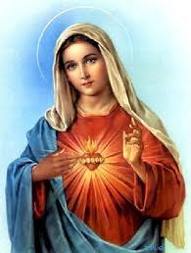
The Angelus

V. The angel of the Lord declared unto Mary.
R. And she conceived by the Holy Spirit.

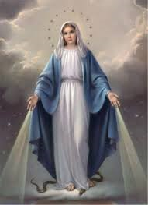

Hail Mary…..

V. Behold the handmaid of the Lord.
R. Be it done unto me according to thy word.

Hail Mary…..

V. And the Word was made flesh.
R. And dwelt among us.
Hail Mary…..

V. Pray for us, O holy Mother of God.
R. That we may be made worthy of the promises of Christ.

Let Us Pray
Pour forth, we beseech Thee O Lord,
Thy grace into our hearts;
that we to whom the Incarnation of Christ,
Thy Son, was made known
by the message of an angel,
may by his Passion and Cross be brought
to the glory of his Resurrection
through the same Christ our Lord.
Amen.

