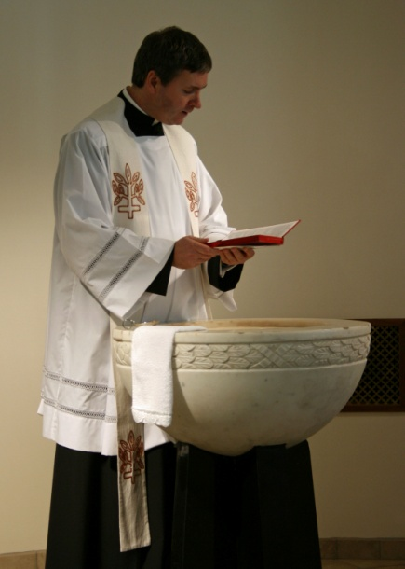 | 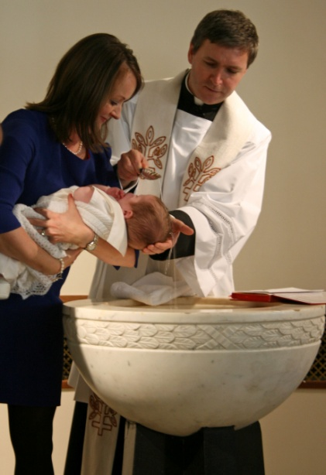 | 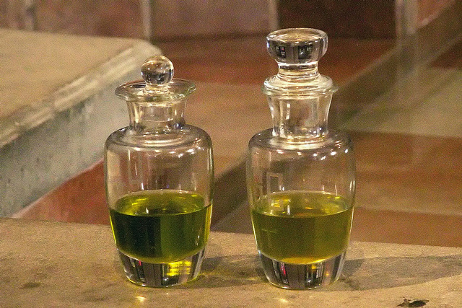
The priest blesses the water. | The priest baptises the baby with Holy Water. | The priest anoints the baby with Holy Oils
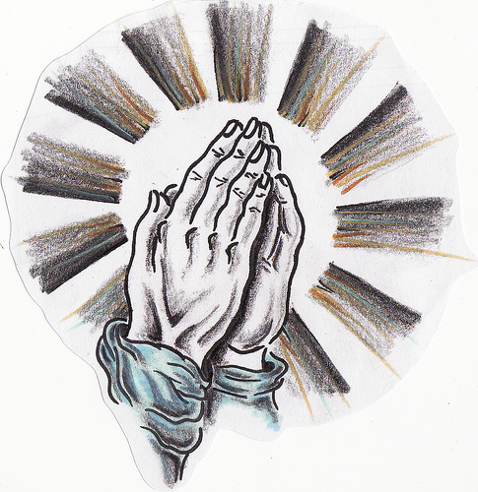 | 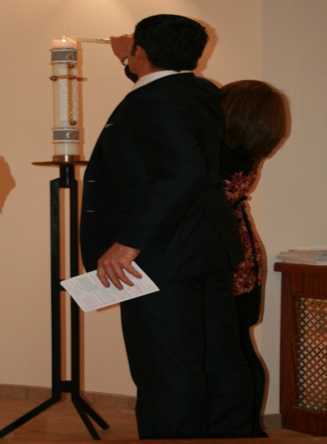 | 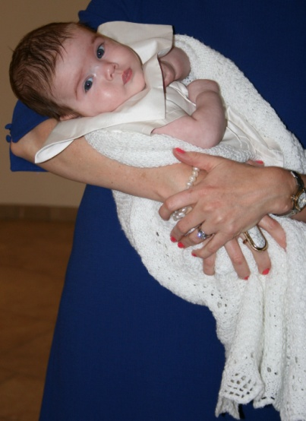
The parents renew Baptismal promises. | The Godparents light Baptismal candle from Paschal candle. | The baby is clothed in a white garment. He is a member of God’s family.

