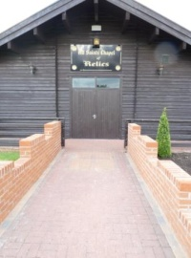
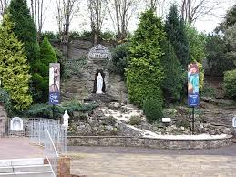
Carfin Lourdes Grotto
All Saints Chapel of Relics

The All Saints Reliquary Chapel was erected in 1998 and was opened the same year by the Bishop of Motherwell, Joseph Devine.
The Chapel contains 735 relics of the saints, of which 536 carry certificates of authentication. It is one of the biggest collections of relics in any one place outside of Rome
Find relics of 3 saints.
Take a photo of what you see.
Write something about the saint OR
tell an adult what you find out.
Saint | What I know /have found out about them
1. | Name:
2. | Name:
3. | Name:

Martyrs: These are saints who were killed because they believed in Jesus.
Find out about 1 Martyr.
Write or tell an adult about them.
Name:

Where they lived:

What they did:

Look around the room and listen to the teacher.
Write or say what you find out.
Centre of the Room:

When was the Carfin Monstrance Blessed?

Location11: (up on the wall)
Who gave Monsignor Taylor the prayer written by St Therese of the Child Jesus?

__________________________________________________________________________________
Location : on floor - silver statue
What flower is associated with St Therese?

Relic 231: Which saints relic is decorated with ornate purple stones (linked to this parish)

__________________________________________________________________________________
Location 16:
Harry Potter’s relative?

Location 18 – Which saint is mentioned here?

__________________________________________________________________________________
Location – shelf above location 19
What is the English town mentioned here and is linked to St Thomas?

Location 20 : Which order of nuns are mentioned here?
__________________________________________________________________________________
Location 21:
What do you think happened at Orange?

__________________________________________________________________________________
General Question:
What saint here is associated with Lourdes?

