In the Garden with Jesus

This meditation is taken from the book Guided Meditations for Children by Jane Reehorst BVM which is now out of print and therefore reproduced here. Please advise if the books is reprinted and the reproductions will be removed from the website.
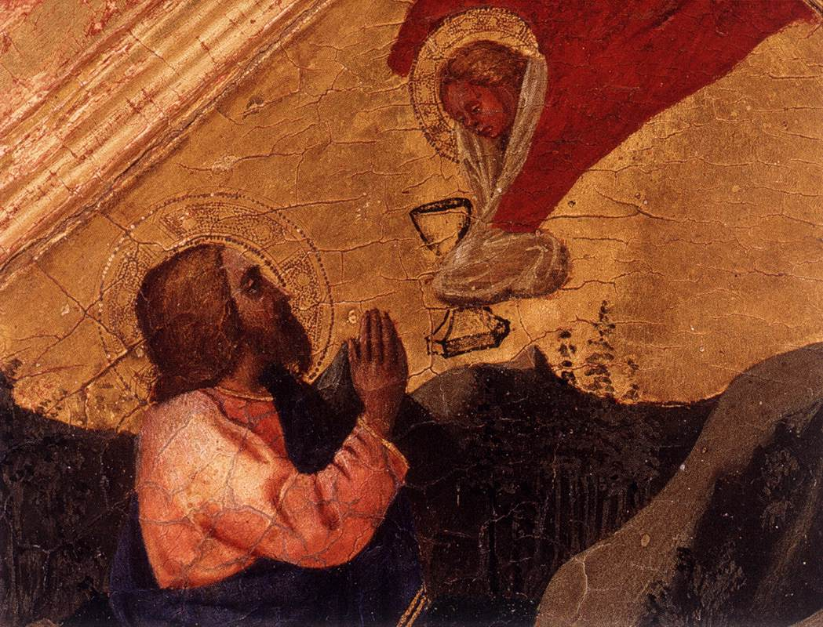
Matthew 26: 36-46

Meditation:

Say: Close your eyes. Take a deep breath, and relax .... Give your wandering thoughts to Jesus .... Take another deep breath, and relax. . . . Feel your whole body relax.
You and the apostles are following Jesus as he leads you down the stone steps from the upper room where you have just finished celebrating the Last Supper .... The clattering of your sandals on the steps is the only sound that breaks the heavy silence that now surrounds you .... Jesus' face is drawn .... His body sags slightly as if he is carrying a heavy burden. ... Jesus is leading you out of the city to the Garden of Gethsemane.
Jesus stops at the entrance to the garden .... "Sit here while I go and pray," he tells the group .... Jesus then turns to Peter, James, John, and you and asks the four of you to follow him .... He leads you farther into the garden .... Jesus stops and turns to you .... "My soul is very sorrowful, even to death," he tells you .... Jesus looks at Peter, James, and John and tells them, "Remain here, and watch with me."
Follow Jesus as he walks a little further into the garden .... Jesus stops again .... His knees begin to bend, ... and his whole body collapses face down onto the ground .... His arms are outstretched before him .... A sob and a deep sigh come from within him .... His body begins to shudder .
Walk closer .... Place your hand on Jesus' shoulder to comfort him .
Feel his body shake .... Jesus begins to plead with his Father .... "My Father, if it be possible, let this suffering pass from me." ... He groans and becomes silent ... Jesus continues his prayer, "Nevertheless, not as I will, but as you will." His body stiffens and then relaxes in silence .... Jesus
slowly lifts himself up ... and rests his hand heavily on your shoulder for help.
Walking over to Peter, James and John, he finds them asleep. ...”So you could not watch with me one hour," Jesus whispers sadly .... Turning from them, Jesus goes back to continue his prayer. "My Father, if this cup of suffering cannot pass unless I drink, your will be done," he prays .... Jesus' clothes and hair are damp with perspiration . . .. Jesus again rises and walks over to his apostles .... He sees they are still asleep .... Jesus sighs and turns away ... This time his prayer is one
of acceptance. His body no longer shakes.
Jesus lifts himself up and rests back on his heels .... Wet strands of hair stick to his forehead and cheek. ... His eyes are filled with sadness as he turns to look at you .... Jesus sees your grief-stricken face, ... places his hand on yours, ... and speaks, "You see I have come to do my Father's will. It's his will that I now suffer and die for the salvation of all. And so, I must continue." ... Rising to his feet, Jesus looks deep into your eyes and says, "I must go now." ... He slowly turns from you and begins to walk toward the entrance to the garden .... You see many torch lights and hear voices shouting outside the garden .... Stay with Jesus .... He needs your love and support at this time of betrayal.
I will give you time to be with Jesus in the moment of his decision to obey his Father.

Prayer
I love you, Jesus. It’s hard to see you suffer. I have a difficult time obeying sometimes. Help me obey like you did - especially when I don't want to. Remind me that my parents and guardian and teachers know what is best for me. Help me respect their wishes, even when I don't understand them. (Invite the children to participate in spontaneous prayer.)

Meditation closing
Say: It’s time to leave Jesus, even though you want to stay and support him ... say goodbye ... give him a hug, and wave goodbye

Read Matthew 26: 36-46 from the bible

Say: Open your eyes, and come back into the room

